## Statement Given: Task I:

**K J Somaiya College of Engineering**

A Constituent College of Somaiya Vidyavihar University Course: Introduction to Project Based Learning

Group 7

## Template for Arduino and LED Interfacing Activity

Interfacing of LEDs and pattern generation

Use Arduino and LED Board to perform following activities

* Different Patterns of LED on- off sequence and duration of on - off time

## Task II:

Interfacing and controlling of LEDs using Push switch Button provided on LED board.

* Control LED on/off patterns with push button input.

## Evaluation Criteria:

1. Connections as per task given,
2. Code for Arduino for the Task.
3. Successful execution of the activities.

## Performance-15 Marks Submission-10 Marks Team

|  |  |  |  |
| --- | --- | --- | --- |
| **Sr No** | **Roll No** | **Name** | **Work Done** |
| 1 | 31 | Dhruti Dutia | Technical |
| 2 | 32 | Divyesh Shirva | Code |
| 3 | 33 | Diya Chugh | Technical |
| 4 | 34 | Gargi Joshi | Information |
| 5 | 35 | Gaurang Sahane | Code |

**Fill your details as per following points**

## Circuit Diagram for the tasks.

* + **Respective codes**

## Photo of Actual implementation

* + **Observations , reflection on activity**

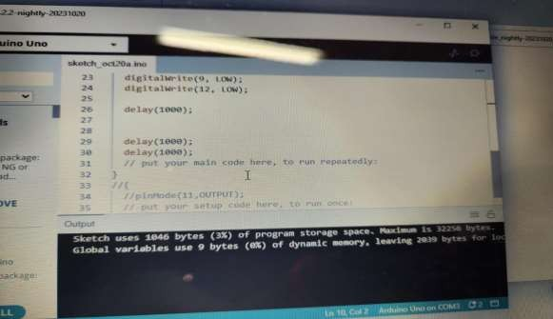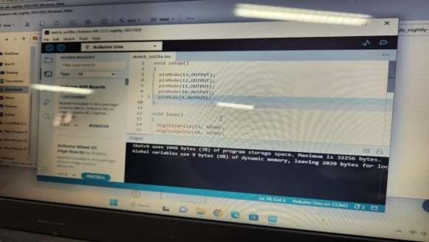

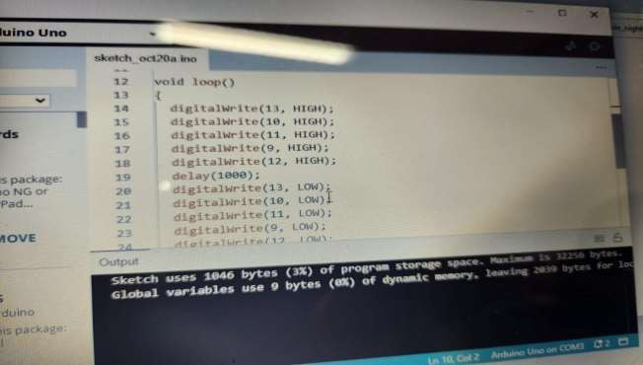

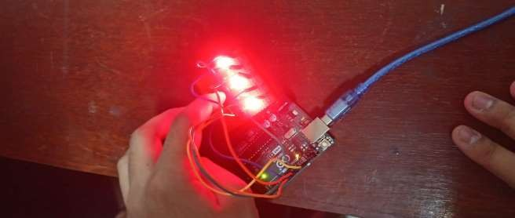





# Technical Skills Development

* Problem-Solving and Troubleshooting

# Learning from Mistakes

* Creativity and Innovation

# Teamwork